YCRY Project Architecture Overview
1. Executive Summary
YCRY is a comprehensive AI-powered parenting assistant designed to help parents interpret their baby's needs and track their development. The core feature is an Audio Analysis System that classifies baby cries (e.g., Hunger, Pain, Tired) using deep learning. The platform also integrates Generative AI (Gemini) for personalized medical and nutritional advice, alongside robust tracking tools for Growth and Vaccination.

2. Technology Stack
Backend
- Framework: Flask (Python)
- Server: Gunicorn (Production), Werkzeug (Dev)
- Asynchronous Tasks: Threading for non-blocking AI inference.
Frontend
- Templating: Jinja2 (Serverside Rendering)
- Languages: HTML5, CSS3, JavaScript (Vanilla + AJAX)
- Visualization: Matplotlib (Server-side plotting), Chart.js (presumed for interactive frontend charts).
Database
- System: MongoDB Atlas (NoSQL)
- Driver: Pymongo
- Data Models:
  - Users: Stores credentials, profile, medical ID.
  - Embedded Documents: Growth logs, Vaccine records, Food logs.
AI & Machine Learning
- Deep Learning Framework: TensorFlow / Keras
- Audio Processing: Librosa (Feature Extraction: Mel Spectrograms)
- Generative AI: Google Gemini (Models: gemini-2.0-flash, gemini-pro, etc.) via google-generativeai SDK.
- Model Architecture: Custom CNN (Convolutional Neural Network)
  - Input: 64x64 Mel Spectrogram Images
  - Layers: 4 Conv Layers (32, 64, 128, 256 filters) + BatchNormalization + Dropout.
  - Output: 5 Classes (Burping, Discomfort, Hunger, Pain, Tired).
External Services
- Email: Flask-Mail (Gmail SMTP) for OTPs and notifications.
- Host: Render (inferred from
Procfile).

3. System Architecture
3.1. High-Level Data Flow
- User Request: Browser sends HTTPS request to Flask Server.
- Controller (app.py): Routes request, handles authentication (Session), and orchestrates logic.
- Model/DB (database.py): Queries MongoDB for user data (Profile, Growth, etc.).
- AI Engine:
  - If Cry Analysis: Audio -> Librosa -> Spectrogram -> CNN Model -> Prediction.
  - If Chat/Advice: Context (Growth/Health) -> Prompt Engineering -> Gemini API -> Text Response.
- View (templates): Renders HTML with dynamic data and returns to user.
3.2. Directory Structure
YCRY/
├── app.py # Main Application Controller / Routes
├── database.py # Database Interface (MongoDB)
├── model_brain.h5 # Pre-trained Keras Model for Cry Analysis
├── preprocess.py # Audio Processing Pipeline (Wav -> Spectrogram)
├── train_model.py # CNN Training Script
├── requirements.txt # Python Dependencies
├── static/ # CSS, JS, Images, Uploads
└── templates/ # HTML Templates (Jinja2)
├── home.html # Dashboard
├── cry.html # Audio Analysis Interface
├── growth.html # Growth Tracking & Charts
├── vaccine.html # Vaccination Schedule
└── ... # Other feature pages

4. Key Modules & Functionalities
4.1. Authentication & Security
- Features: Registration, Login, Logout, Forgot Password.
- Security:
  - Passwords hashed using Bcrypt.
  - 6-Digit OTP for password resets (via Email).
  - Session-based authentication with login_required checks on all protected routes.
4.2. Cry Analysis System (/cry)
- Input: User uploads/records audio (.wav).
- Processing:
  - Pre-processing: Audio loaded via librosa, truncated/padded to 5-7 seconds.
  - Feature Extraction: Converted to Mel Spectrogram.
  - Visualization: Spectrogram saved as a temporary image.
  - Inference: CNN (
model_brain.h5) predicts classprobabilities.
- Output: Prediction (e.g., "Hunger"), Confidence Score (%), and Actionable Advice.
4.3. Intelligent Growth Tracker (/growth)
- Logging: Users log Weight (kg) and Height (cm).
- Visualization: Historical charts showing growth trends.
- AI Analysis: Sends growth history + birth vitals to Gemini AI to analyze trends (steady gain, BMI check) and provide pediatrician-style tips.
4.4. Smart Vaccination System (/vaccine)
- Scheduler: Calculates due dates based on Baby's DOB vs. standard immunization schedule (0, 6, 10, 14 weeks, etc.).
- Status Tracking: Tracks Upcoming, Completed, and Overdue vaccines.
- Alerts: Visual warnings (Red/Green badges) on Dashboard for overdue shots.
4.5. Nutrition & Food Safety (/nutrition)
- Static Guides: Age-appropriate food rules (0-6m, 6-8m, etc.).
- AI Features:
  - Safety Checker: Ask "Can baby eat honey?" -> AI analyzes safety for specific age.
  - Recipe Gen: Generates baby-friendly recipes.
  - Meal Planner: Creates 1-day meal plans based on culture/diet.
- Food Log: Tracks what baby ate and any allergic reactions (which auto-update the Medical ID).
4.6. Dr. Ycry AI Assistant (/api/chat)
- Persona: "Dr. Ycry" - a warm, empathetic pediatrician.
- Context-Aware: The system injects the baby's real-time data (Age, Name, Growth History, Vaccine Status) into the system prompt.
- Capability: Answers parenting questions with specific reference to the child's actual health data.
4.7. Admin Dashboard
- Access: Restricted to users with is_admin=True.
- Features: View all registered users, Delete users.

5. Machine Learning Detail
Audio Classification Model
- Type: Custom Convolutional Neural Network (CNN).
- Architecture:
  - Conv2D (32 filters) -> BatchNorm -> MaxPool
  - Conv2D (64 filters) -> BatchNorm -> MaxPool
  - Conv2D (128 filters) -> BatchNorm -> MaxPool
  - Conv2D (256 filters) -> BatchNorm -> MaxPool
  - Flatten -> Dense (256) -> Dropout (0.5) -> Dense (5, Softmax).
- Performance: Optimized with Class Weights (balanced) and Data Augmentation (Shear, Zoom, Shift).
Generative AI Integration
- Strategy: Multi-Model Fallback.

6. Architecture Visualization
6.1. High-Level System Architecture
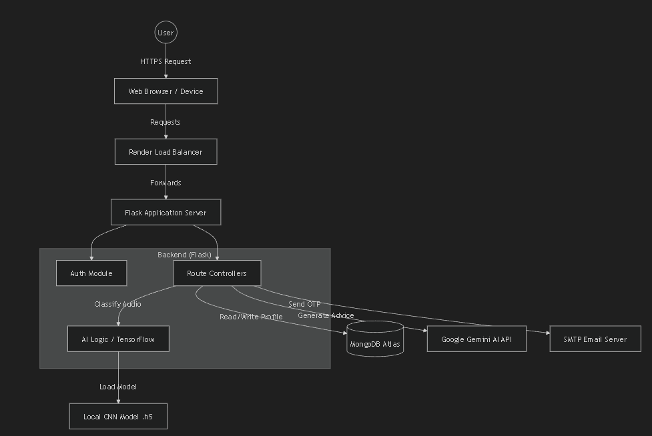

6.2. Cry Analysis Workflow
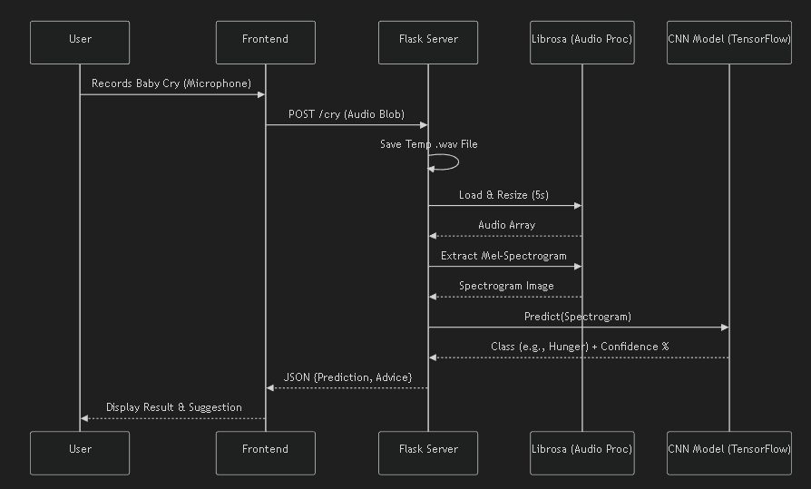
6.3. AI Assistant & Data Flow
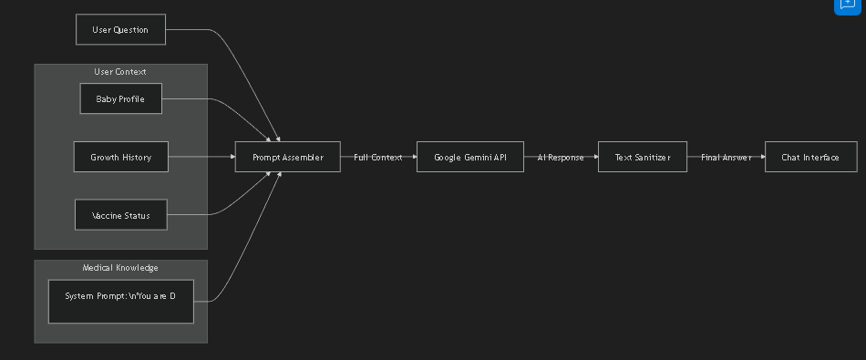

YCRY - AI-Powered Parenting Assistant
YCRY is a comprehensive, intelligent parenting assistant application designed to help parents decode their baby's needs, track development, and manage health records. It leverages Artificial Intelligence (AI) for cry analysis and provides a centralized platform for vaccination tracking, growth monitoring, and nutritional guidance.
🚀 Core Features
1. AI Cry Translator (/cry)
- Functionality: Analyzes audio recordings of a baby's cry to determine the likely cause.
- Technology: Uses a Convolutional Neural Network (CNN) trained on Mel-spectrograms of baby cries.
- Categories: Detects 5 main states:
  - Hunger
  - Pain
  - Tiredness
  - Burping
  - Discomfort
- Output: Provides a prediction with a confidence score and actionable advice (e.g., "Feed baby", "Check diaper").
2. Vaccine Tracker (/vaccine)
- Smart Scheduling: Automatically generates a vaccination schedule based on the baby's Date of Birth (DOB).
- Status Tracking: Tracks vaccines as "Upcoming", "Completed", or "Overdue".
- Alerts: Displays visual warnings for overdue immunizations.
- Calendar Integration: Allows adding vaccine appointments directly to Google Calendar.
- Covers: Major vaccines like BCG, OPV, Hep-B, DTwP, IPV, Measles, and MMR.
3. Growth Journey (/growth)
- Tracking: Logs Weight (kg) and Height (cm) over time.
- Visualization: Displays growth charts using historical data.
- Milestones: Provides age-appropriate developmental milestones (Motor, Social, Communication) based on the baby's current age.
- AI Analysis: "Dr. Ycry" analysis feature interprets growth trends and gives personalized feedback.
4. Smart Nutrition Guide (/nutrition)
- Age-Specific Advice: strict guidelines on what is allowed/avoided for 0-6m, 6-8m, 8-10m, and 10-12m+ stages.
- Food Log: Tracks new foods introduced and the baby's reaction (Loved, Okay, Disliked, Allergy).
- AI Integration:
  - Safety Check: Ask if a specific food is safe for the baby.
  - Meal Plans: Generate 1-day meal plans.
  - Recipes: Get simple, baby-friendly recipes.
- Auto-Allergy Sync: If a food reaction is marked as "Allergy", it automatically updates the Medical ID.
5. Health & Medical ID (/health)
- Medical Profile: Stores Doctor's contact, Insurance details, and Allergies.
- Warning Signs: Quick reference guide for emergency symptoms (Fever, Dehydration, Breathing trouble).
- BMI/Status: Basic health status assessment based on birth metrics (Weight, Apgar score, Head/Chest circumference).
6. AI Assistant "Dr. Ycry" (/assistant)
- Chat Interface: A conversational AI chatbot acting as a pediatrician.
- Context-Aware: Knows the baby's name, age, growth history, and vaccine status to provide personalized answers.
- Backend: Powered by Google's Gemini models (with fallback logic across multiple model versions).
7. Developmental Exercises (/exercises)
- Activity Guide: Suggests age-appropriate exercises (e.g., Tummy Time, Visual Tracking).
- Video Tutorials: Links to YouTube videos for demonstrating exercises.
🛠️ Technical Stack
Backend
- Framework: Flask (Python)
- Database: MongoDB (via PyMongo)
- Authentication: Session-based auth with bcrypt for password hashing.
- AI/ML:
  - TensorFlow/Keras: For the custom Cry Analysis CNN model (
model_brain.h5).
  - Librosa: For audio processing and Mel-spectrogram generation.
  - Google Gemini API: For the Chatbot, Growth Analysis, and Nutrition advice.
- Email: Flask-Mail for OTP-based password resets.
Frontend
- Templating: Jinja2 (HTML templates)
- Styling: Tailwind CSS (Modern, utility-first styling) & Custom CSS.
- Interactivity: Vanilla JavaScript (AJAX for logs, seamless updates).
- Visuals: Glassmorphism design system, AOS (Animate On Scroll) for animations.
Infrastructure
- Environment: managed via
.env (API Keys, DB Query Strings).
- Static Assets: Stores user profile pictures and temporary audio uploads in static/.
📂 Project Structure Overview
- app.py: Main application entry point, route definitions, and controller logic.
- database.py: MongoDB connection, CRUD operations, and data models.
- model_brain.h5: Pre-trained Keras model for cry classification.
- templates/: HTML files for all pages (
home,
cry,
vaccine, etc.).
- static/: CSS, JS, Images, and file uploads.
- requirements.txt: Python dependencies.
🔐 Security & Data
- User Isolation: All data (Growth, Vaccines, Logs) is isolated per user account.
- Session Management: Secure session handling with logout on server restart (random secret key).
- Input Validation: Robust checks for registration data (negative weights, invalid Apgar scores).

CNN Architecture Breakdown
1. The Input
The librosa library processes the raw audio
.wav file into a visual Mel Spectrogram image, formatted to 64x64 pixels with 1 color channel (grayscale/depth).
2. The Convolutional Blocks
The model passes the image through 4 distinct Conv2D -> BatchNorm -> MaxPool sequences to extract audio features:
- Block 1: Uses 32 filters. Reduces spatial size to 32x32.
- Block 2: Uses 64 filters. Reduces spatial size to 16x16.
- Block 3: Uses 128 filters. Reduces spatial size to 8x8.
- Block 4: Uses 256 filters. Reduces spatial size to 4x4.
3. The Dense Layers (Classification)
- Flatten Layer: Converts the 2D feature maps from the final convolutional block into a 1D array of 4,096 numbers.
- Dense Layer (256): A fully connected hidden layer that learns the complex relationships between the features.
- Dropout (0.5): Randomly ignores 50% of the neurons during training to prevent overfitting.
- Final Output Layer: A Dense layer with 5 Neurons and a Softmax activation function, outputting the probability distribution across the 5 possible classes (Hunger, Pain, Discomfort, Tiredness, Burping).

This model essentially treats audio processing like image recognition by converting the sound into a visual format (a spectrogram) and using a CNN to look for visual patterns that correspond to different types of baby cries.
1. The Input Stage
- Input Data: The model takes a Mel Spectrogram as its input. This is a visual representation of the audio signal where the X-axis represents time, the Y-axis represents frequency (pitch), and the colors represent the amplitude (loudness).
- Dimensions: The input image is sized at 64x64 pixels with 1 channel (meaning it operates like a grayscale or single-color heatmap image, rather than a 3-channel RGB image).
2. Feature Extraction (The Convolutional Blocks)
The core of the network consists of four repeating blocks. Each block follows the exact same sequence: Conv2D -> Batch Normalization -> MaxPooling. As the data passes through these blocks, the spatial dimensions (Height/Width) shrink, but the depth (number of filters) increases, allowing the model to learn increasingly complex features.
- Block 1:
  - Conv2D: Applies 32 filters (using a 3x3 kernel) to detect basic patterns. The depth becomes 32.
  - Batch Normalization: Stabilizes and speeds up training by normalizing the outputs of the previous layer.
  - MaxPooling (2x2): Shrinks the image size by half, reducing the dimensions from 64x64 to 32x32, keeping the most prominent features.
- Block 2:
  - Conv2D: Increases to 64 filters.
  - Batch Normalization & MaxPooling: Shrinks the spatial dimensions down to 16x16.
- Block 3:
  - Conv2D: Increases to 128 filters.
  - Batch Normalization & MaxPooling: Shrinks the spatial dimensions down to 8x8.
- Block 4:
  - Conv2D: Increases to 256 filters.
  - Batch Normalization & MaxPooling: Shrinks the spatial dimensions down to 4x4.
  - Result: At the end of this block, the data is a small but very deep 3D block sized at 4x4x256.
3. The Classification Head (Dense Layers)
Once the visual features are extracted, the model needs to translate them into an actual decision.
- Flatten: This layer takes the 3D block (4x4x256) and unrolls it into a single, flat 1D line of numbers. $4 \times 4 \times 256 = 4096$, so this results in 4096 Neurons.
- Dense (256 Neurons): A fully connected layer that analyzes the flattened 4096 data points and boils them down to 256 core features.
- Dropout (0.5): This is a safety measure used during training. It randomly turns off 50% (0.5) of the neurons. This forces the network to not rely too heavily on any single neuron, preventing "overfitting" (where the AI memorizes the training data instead of actually learning the patterns).
- Dense (5 Neurons, Softmax): This is the final output layer. It contains exactly 5 neurons, corresponding to the 5 possible cry classifications. The "Softmax" function ensures that the outputs are converted into percentages (probabilities) that add up to exactly 100%.
4. The Output Stage
The model outputs a probability score for 5 distinct classes:
- Hunger
- Pain
- Discomfort
- Tiredness
- Burping
The class with the highest probability bar (as illustrated by the small bar charts on the right) becomes the model's final prediction.

